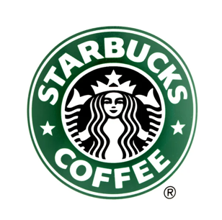**Introduction:**

**STARBUCKS**

Starbucks is a renowned global brand known for its premium coffee such as Espresso, Cappuccino, Cold Brew & Hot chocolate, as well as a range of other beverages such as smoothies, Brewed Teas, along with various food items. Starbucks has become world famous and brings high quality coffee and beverages to its clients over the world daily.

Marketing analytics is the practice of using data to evaluate the effectiveness and success of marketing activities. It enables businesses to gain deeper insights into their customers and optimize their marketing objectives to achieve higher ROI on marketing investments. This analysis also ensures that consumers see a greater number of targeted, personalized ads that speak to their specific needs and interests, rather than mass communications that tend to annoy.

The case study focuses on Starbuck’s use of marketing analytics and how it has helped the company make informed decisions, drive customer engagement, and achieve sustainable growth in the coffee industry. The case study explores the specific methodologies, tools, and techniques employed by Starbucks in their marketing analytics initiatives. It also discusses the challenges faced and the lessons learned from their journey.

**Background:**

Starbuck’s story began in 1971 along the cobblestone streets of Seattle’s historic Pike Place Market. It was here where Starbucks opened its first store, offering fresh-roasted coffee beans, tea and spices from around the world for their customers to take home. Their name was inspired by the classic tale, “Moby-Dick,” evoking the seafaring tradition of the early coffee traders.

Ten years later, a young New Yorker named Howard Schultz walked through these doors and become captivated with Starbucks coffee from his first sip. After joining the company in 1982, a different cobblestone road led him to another discovery. It was on a trip to Milan in 1983 that Howard first experienced Italy’s coffeehouses, and he returned to Seattle inspired to bring the warmth and artistry of its coffee culture to Starbucks. By 1987, Starbucks swapped its brown aprons for green ones and embarked on their next chapter as a coffeehouse.

Starbucks soon expanded to Chicago and Vancouver, Canada and then on to California, Washington, D.C. and New York. By 1996, it crossed the Pacific to open its first store in Japan, followed by Europe in 1998 and China in 1999. Over the next two decades, it grew to welcome millions of customers each week and became a part of the fabric of tens of thousands of neighbourhoods all around the world. In everything they do, they are always dedicated to their Mission: With every cup, with every conversation, with every community - they nurture the limitless possibilities of human connection.

According to a survey of 2023, Starbucks has 100 million customers all across the globe. Starbucks makes up to $3800 per day from the company owned stores which translates to a profit of $520 per store per day.

**Objectives:**

One of the main objectives was to increase its customer base and sales revenue. To achieve this objective, Starbucks used marketing analytics to identify customer preferences and trends, which helped them to create targeted marketing campaigns that resonated with their customers.

Another objective was to increase brand awareness and loyalty. Starbucks used social media analytics to track customer engagement and feedback, which helped them to create more personalized experiences for their customers.

By using analytics, Starbucks was able to identify new opportunities for growth, develop targeted marketing campaigns, and improve customer engagement.

These objectives were linked to the overall business goals of Starbucks which were to increase profitability, expand globally, and maintain its position as a market leader in the coffee industry.

**Challenges:**

* ***Competition from other coffee chains and independent coffee shops:***

This can impact Starbucks’ market share, customer traffic, and profitability and also put pressure on the company to continually innovate and improve its offerings in order to remain competitive.

* ***Changes in consumer preferences or trends:***

It could impact the demand for certain Starbucks products or put pressure on the company to adapt its offerings to meet these changing preferences and also impact the way Starbucks does business and require the company to adapt its operations in order to remain competitive.

* ***Economic downturns or market instability:***

During times of economic uncertainty or recession, consumers may be more cautious about their spending and may choose to patronize lower-priced options or cut back on discretionary purchases, such as coffee or food items. Market instability can also impact the cost of raw materials or other inputs used to produce Starbucks products, which can impact the company’s margins and profitability.

* ***Supply chain disruptions or sourcing challenges:***

It can impact the price and availability of raw materials and other inputs used in the production of its products. Transportation delays or natural disasters, can impact the availability of certain ingredients or materials, which in turn impacts production and profitability. The cost and dependability of the company’s supply chain may also be affected by sourcing difficulties, such as a lack of access to suppliers that can fulfill the company’s quality and sustainability standards.

* ***Labor disputes or employee turnover:***

It can impact the company’s ability to provide a consistent customer experience and may require more time and resources to train new employees. This can also impact the company’s reputation and employee morale. To address this threat, Starbucks may need to implement strategies such as employee training programs, employee retention initiatives, and fair and competitive compensation and benefits packages in order to reduce the risk of labor disputes and improve employee retention.

**Data Collection and Analysis:**

***Data sources Starbucks employ for marketing analytics:***

* ***Esri’s technology platform:***

Starbucks contracts with a location-analytics company called Esri to use their technology platform that helps analyse maps and retail locations. It uses data like population density, average incomes, and traffic patterns to identify target areas for a new store.

* ***Third-Party Data:***

Starbucks may also leverage third-party data sources to enrich its understanding of customer behaviour. These sources include demographic data, consumer research reports, and external market data. Third-party data helps Starbucks gain a broader perspective on customer segments, market trends, and competitive insights. It allows the company to enhance its targeting and segmentation strategies.

* ***In-Store Technology:***

Starbucks utilizes various in-store technologies, such as Wi-Fi tracking, digital menu boards, and mobile order data. These technologies capture customer footfall, dwell time, and ordering preferences.

In-store technology data helps Starbucks optimize store layouts, product placements, and menu offerings. It also contributes to understanding customer behaviour within physical store environments.

***Data collection methods Starbucks employ for marketing analytics:***

* ***Social Media Monitoring:***

Starbucks has continuously tracked who tagged them in their posts, tweets and images and monitored different social media to understand consumer needs, concerns, and feedback.

This component of Starbuck’s market research strategy is an opportunity for online reputation management (ORM) to ensure customer satisfaction.

While monitoring, Starbucks analyses the social media sentiment, or the mood that is portrayed through the engagement to make it actionable feedback.

* ***Point-of-Sale (POS) Data:***

Starbucks collaborated with oracle and together they made a special POS system specifically for Starbucks. It’s called Simphony. The features of the Oracle Simphony POS include Smart Navigation, Speech-Style Ordering, Table Service, Mobile POS Integrations, App Integration, Kiosk Options, Data Storage.

Starbucks collects data from its point-of-sale systems, which capture transactional information such as purchase details, order size, specific products, and time of purchase. POS data provides valuable insights into customer buying patterns, popular items, and sales trends at individual stores. It helps Starbucks understand customer preferences and optimize product offerings.

* ***Customer Surveys:***

Starbucks Customer Survey contains a short series of questions about your order and the service you received with their employees in store. The feedback is completely anonymous and will be used to support in how Starbucks work on any opportunities to improve customer’s future visits.

Starbucks actively collects customer feedback through surveys, comment cards, and digital channels. These surveys capture insights on customer satisfaction, preferences, and experiences. Customer surveys provide qualitative data that complements quantitative data, offering rich insights into customer perceptions, brand loyalty, and areas for improvement.

* ***Digital Interactions and Mobile Apps:***

Starbucks uses the massive amount of data collected from their app to personalize the customer’s Starbucks experience by gathering information about their coffee buying habits, from their favourite drinks to what time they typically order. This will allow personalization of the experience to happen at the new locations they visit, and the app will provide suggestions of what customers might be interested in trying. They applied the Digital Flywheel program, which merges digital and physical customer interactions around rewards, personalization, payments and orders. Each interaction with the end user generates qualitative and quantitative information and data to provide insights on where and how to create new value and turn in the next round of innovation. For example, it can help Starbucks recommend food and beverages to customers who don’t know but are willing to try them, with recommendations updated with different factors, such as weather, holidays, location, etc.

***Tools and techniques* *Starbucks employ for marketing analytics:***

***Predictive Analysis:***

Starbucks now generates recommendations for customers approaching their stores, using location data to know when customers are approaching. Starbucks segments its customers with data and Machine Learning, then sets up rules based on decision trees mapping their purchase behaviour. Then, the customers get offers, usually on their smartphones. With this they can tell you how much customers spend on average, and, for example, they know on Thursday you are most likely not alone and spend a little extra, buying a blueberry muffin and two Venti lattes. From customer’s purchase habits, along with other insights, they work on targeting them so that they increase that average spend and buy a cupcake crème Frappuccino and a chocolate chip cookie on Monday to treat themselves.

Tools used for statistical analysis also include Descriptive analysis and Segmentation.

**Customer Segmentation:**

Starbucks carefully selects variables and criteria that are relevant and impactful in understanding customer behaviour and preferences. These variables can include factors like age, gender, location, spending habits, frequency of visits, preferred products, engagement with digital platforms, and more. The selection process is driven by data analysis and customer insights to ensure the chosen variables accurately represent meaningful differences among customers.

The criteria and variables considered in the segmentation process:

Starbuck’s market segmentation strategy encompasses four variables:

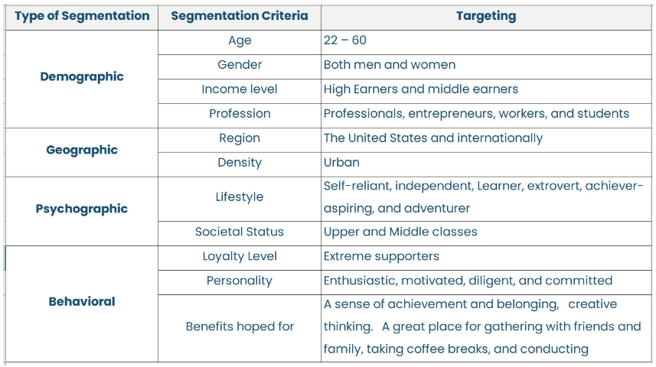

* ***Demographic***

Starbucks targets both males and females, including professional employees and students, aged between 22–60 years. The company also targets single individuals, older married couples with children, and young children under and over six years old.

* ***Geographic***

Geography is another key consideration in Starbucks’ targeting approach, with the company serving multiple chains worldwide. Therefore, wherever a Starbucks chain exists, it is included in the geographic aspect of the targeting. This includes various regions across the globe, such as Latin America, the US, Canada, the Middle East, Europe, China, Africa, Asia, and the Pacific.

* ***Psychographic***

It is related to the lifestyle and social status. In it, Starbucks is focusing on independent extrovert and adventure people

* ***Behavioural***

Starbucks uses behavioural segmentation to target their regular morning customers with an incentive to get them back in for another purchase later in the day. Since these regular users will likely have an afternoon coffee on occasion, Starbucks uses email marketing and push notifications within their mobile app to offer happy hour events.

**4Ps Method:**

***People***

The company also offers its customers birthday treats during this special day to enable them to view the enterprise as a caring entity. The sentimental value of birthdays is the main marketing aspect of this promotion. More customers view the company as a brand that holds their lives in high regard.

***Promotion***

The efficiency of the Starbucks reward systems has also provided immense exposure and marketing for the corporation. More customers have become regulars at the premises, motivated by the possibility of the rewards guaranteed after a certain limit is achieved. This marketing initiative has borne success for the company, as it reported positive turnovers for the third quarter.

***Place***

Additionally, the corporation hastened its delivery of coffee and other beverages to varied locations to ensure their customers choose the venue they enjoy their beverages. The drive-thru stations also means that customers can spend limited time at the stores whenever their time is limited. This ensures convenience at the venue, an aspect the company is renowned for as a luxury brand.

***Price***

Starbucks has also invested in days when the customers can earn twice the stars, they earn on normal days by buying the same products. This feature is dedicated to some days of the week and the customers must be on the look-out to ensure that such days do not pass them. During days like this, the company enjoys higher sales and higher profits. The clients are usually aiming for their stars to achieve required limits quicker for redeeming.

**Customer Lifetime Value method:**

The customer lifetime value method is the projected revenue that a customer will generate during their lifetime. According to the Starbucks case study, if we calculate the average spending of a Starbucks customer multiplied by the number of visits per week, we obtain that this customer will bring Starbucks a $14,099 profit in their lifetime. Respecting this prediction, Starbucks should not spend more than this amount in advertising and customer retention techniques, and this budget limit allows them to maintain high profits without excessively spending on advertising. Having a set budget, Starbucks can send promotional messages to their customer and offer them reduction coupons on their favourite products; benefits are mutual, customers purchase at lower prices and Starbucks has a constant cash flow in their stores.

**Customer Relationship Management:**

At Starbucks the membership card plays a role in tracking the number of sales per customer and helps determine whether it is worth investing in keeping this customer. Starbucks' store managers are equipped with personal laptops that help them share their experience with other store managers via the company cloud, and they can exchange opinions to improve customer satisfaction. One of the most successful CRM launches was the Starbucks mobile app through which customers could pay at Starbucks – within a year Starbucks handled 20 million transactions in total

**Personalization, Loyalty and Social programs**

***Personalised Program***

The coffee giant is in many ways on the cutting edge of using big data and artificial intelligence to help direct marketing, sales, and business decisions for marketing data analysis and data-driven decision-making. Starbucks Rewards loyalty program has over 14 million members. Rewards represented 36% of U.S. company-operated sales last year and mobile payment was 29 percent of transactions. By knowing what loyalty customers are ordering and how often they order it, Starbucks can send consumers personalized offers and marketing materials to help drive more sales.

One of the details you may not think about but is quite powerful is that each and every time you go to Starbucks the Barista greets you, asks for your name and then writes your name on your order. For a large retailer like Starbucks, which serves more than [100 million customers](https://business.financialpost.com/pmn/business-pmn/starbucks-ceo-sees-more-stores-faster-innovation-as-key) per week, that’s an impressive feat, the ability to greet each and every customer by name.

***Loyalty Program***

The Starbucks Reward Loyalty Program has a staggering 16 million active members (as of March 2019), with 11% growth of their user base in Q2 2018. Starbucks attributes 40% of its total sales to the Rewards Program and has seen same store sales rise by 7%. The Reward Program is available on mobile devices as the Starbucks app, and has seen impressive membership and growth since 2008, with multiple iterations on its original form. The investment made into the mobile interface has increased the frequency and spend of both regular and occasional customers. Starbucks uses this tool to individually market specific products and features based on data collected from the app about its users. Customers can order and pay through the app ahead of arriving at a physical location, as well as earn stars (rewards) that translate into free drinks, food, and merchandise.

***Social Responsible Programs***

Starbucks is working on improving the access to education and rehab agricultural training as well as increasing their levels of overall health among other things in backward areas

**Data Analysis done on Starbucks’s data**

Based on the available data from 2014 to 2018, we implemented marketing analytics to analyse profiles, portfolios and transcript of their customers. The graphical representation as “Gender Distribution” and “Income Distribution” analyse the demographic variables of customers that will be helpful for company in targeted advertisement, decision-making and strategy formulation. The “Type of Offers” chart showcases offers that can be implemented to attract a large customer base because it gives clear performance overview of different offers. Additionally, “Channel Distribution” graph represents the most effective medium employed to reach customers and the highest sales generating medium. The “Difficulty of Duration” chart indicates the level of difficulty in terms of time, Starbucks encounter in persuading customers. This can help company to identify difficult or time-consuming customer segments and optimise them to make the task easier. Bivariate analysis has been conducted to illustrate the relationship between customer’s income and their gender for product development, pricing and CLV analysis. For customer segmentation, the elbow method has been utilised to determine the optimal number of clusters which has been identified as 3.

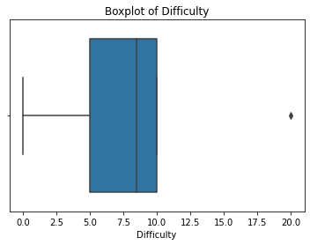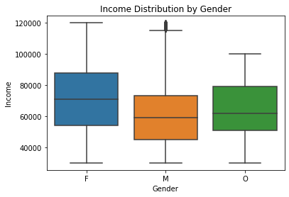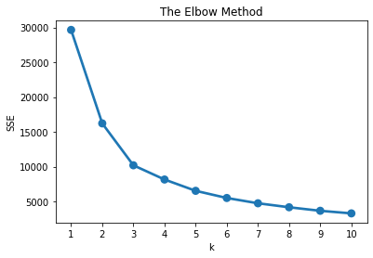

These charts provide valuable insight into various crucial variables, customer satisfaction level, brand performance and the impact of offers. Starbucks can leverage this information to make data-driven decisions that can enhance their marketing strategies and improve their product offerings and promotional schemes. By utilising this information, Starbucks can effectively meet customer expectations and ensure that their initiatives aligned with customer preferences and demand.

**GitHub Link**

<https://github.com/sohamsv/Starbucks-Data-Analysis-Customer-Segmentation>s

**Conclusion and Recommendations**

Even after having the global success and recognition, Starbuck has threat from its rivals and to protect Starbucks’s business against imitation is to aggressively innovate, especially in the area of product development and targeted advertisement. Innovation can make the company’s products more difficult to imitate. It is also recommended that Starbucks Corporation consider pricing strategies and offers that attract more customers. For instance, bundle pricing can help address the threat of competition involving low-cost sellers. Furthermore, a suitable recommendation in this case is to implement creative marketing and branding strategies that build Starbucks’s corporate image as a contributor to community development. Such an image can help reduce sociocultural opposition against the company’s expansion. These recommendations focus on minimizing the negative impacts of the internal and external factors enumerated in our analysis.

**Summary**

Starbucks employs various data collection methods and marketing analytics techniques, supported by ML algorithms, to analyse the customer behaviour segmentation and 4Ps. These technologies empower Starbucks to deliver personalised offers, implement effective loyalty programs and optimise overall customer experience. In addition, Starbucks is committed to social responsibility and actively engages in various schemes targeting diverse populations and help them in evolving the company also leverage customer life value methods and customer relationship management to optimise its strategies despite facing competition from rivals Starbucks set objectives to achieve. By leveraging these tools, Starbucks can ultimately improve satisfaction and engagement of their customers with the brand.

**References**

<https://www.researchgate.net/publication/284112548_Starbucks_Marketing_Analysis>

<https://www.marketingevolution.com/marketing-essentials/marketing-analytics#:~:text=Marketing%20analytics%20is%20the%20practice,benefits%20both%20marketers%20and%20consumers>.

<https://scholar.harvard.edu/files/nithingeereddy/files/starbucks_case_analysis.pdf>

[https://www.starbucks.com/about-us/#](https://www.starbucks.com/about-us/)

[Starbucks SWOT Analysis (2023) (businessmodelanalyst.com)](https://businessmodelanalyst.com/starbucks-swot-analysis/)

[Marketing Objectives of Starbucks Assignment | Online Help (locusassignments.com)](https://www.locusassignments.com/solution/marketing-objectives-starbucks-assignment)

<https://toppossystem.com/what-pos-system-does-starbucks-use/>

<https://www.driveresearch.com/market-research-company-blog/starbucks-market-research-strategy/>

[Starbucks’ secret ingredient: data analytics - Digital Innovation and Transformation (harvard.edu)](https://d3.harvard.edu/platform-digit/submission/starbucks-secret-ingredient-data-analytics/)

[Starbucks Corporation Using Data Analytics | Free Essay Example (studycorgi.com)](https://studycorgi.com/starbucks-corporation-using-data-analytics/)

<https://edubirdie.com/examples/challenges-of-starbucks-as-a-coffeeshop/>